**VISVESVARAYA TECHNOLOGICAL UNIVERSITY**

**“JnanaSangama”, Belgaum -590014, Karnataka.**



**PROJECT WORK-1 REPORT**

**on**

**ANIME CATALOGUE**

**WEBSITE**

***Submitted by***

**JAYANTH B (1BM20CS227)**

**MISBAH RIYAZ (1BM20CS226)**

***Under the Guidance of***

**Prof. Sowmya V**

**Assistant Professor, BMSCE**

***In Partial Fulfillment for The Award of The Degree Of***

**BACHELOR OF ENGINEERING**

***in***

**COMPUTER SCIENCE AND ENGINEERING**



**B.M.S. COLLEGE OF ENGINEERING**

**(Autonomous Institution under VTU)**

**BENGALURU-560019**

**Sep-2020 to Jan-2021**

**B. M. S. College of Engineering,**

**Bull Temple Road, Bangalore 560019**

(Affiliated To Visvesvaraya Technological University, Belgaum)

**Department of Computer Science and Engineering**



**CERTIFICATE**

This is to certify that the project work entitled “**ANIME CATALOGUE WEBSITE**” carried out by **JAYANTH B (1BM20CS227)** and **MISBAH RIYAZ (1BM20CS226)** who are Bonafede students of **B. M. S. College of Engineering.** It is in partial fulfillment for the award of **Bachelor of Engineering in Computer Science and Engineering** of the Visveswaraya Technological University, Belgaum during the year 2020-2021. The project report has been approved as it satisfies the academic requirements in respect of **Project Work-1 (19CS3PWPW1)** work prescribed for the said degree.

Signature of the Guide                 Signature of the HOD

Prof. Sowmya V Dr. Jyothi S Nayak

Assistant Professor Prof.& Head of Dept. of CSE

BMSCE, Bengaluru BMSCE, Bengaluru

External Viva

Name of the Examiner                                                                                       Signature with date

1._____________________________ ________________________

2. _____________________________ _________________________

**B.M.S. COLLEGE OF ENGINEERING**

**DEPARTMENT OF COMPUTER SCIENCE AND ENGINEERING**



**DECALARATION**

We, **JAYANTH B (1BM20CS227)** and **MISBAH RIYAZ (1BM20CS226),** students of 3rd Semester, B.E, Department of Computer Science and Engineering, B. M. S. College of Engineering, Bangalore, here by declare that, this Project Work-1 entitled "Anime Catalogue Website" has been carried out by us under the guidance of SOWMYA V, Assistant Professor, Department of CSE,

B. M. S. College of Engineering, Bangalore during the academic semester Oct 21 – March 22

We also declare that to the best of our knowledge and belief, the development reported here is not from part of any other report by any other students.

Signature

**JAYANTH B (1BM20CS227)**

**MISBAH RIYAZ(1BM20CS226)**

**TABLE OF CONTENTS**

1. INTRODUCTION
2. FUNCTIONALITIES
3. HOME PAGE

-HOME

-EXPLORE

-ABOUT

-BTS

-DASHBOARD

-CONTACT

1. PROJECT LAYOUT
2. SOURCE CODE

1. INTRODUCTION

Website development for “Anime Catalogue Website” topic.

**1.1 ABOUT THE WEBSITE**

The name of this website is “ANI-GUIDO”, meaning a guide for anime shows. It has information - number of seasons, creators and details- summary, characters about popular shows. It provides links to legal streaming sites to watch the shows.

**1.2. ABOUT THE PROJECT**

Taking a break from the regular stressful routine of daily life is a must for everyone out there. What is better than some good quality anime to binge? Our site helps the user to choose which show is best for them according to their taste, and genre preferences.

**1.3 FUNCTIONALITIES**

* Login for User

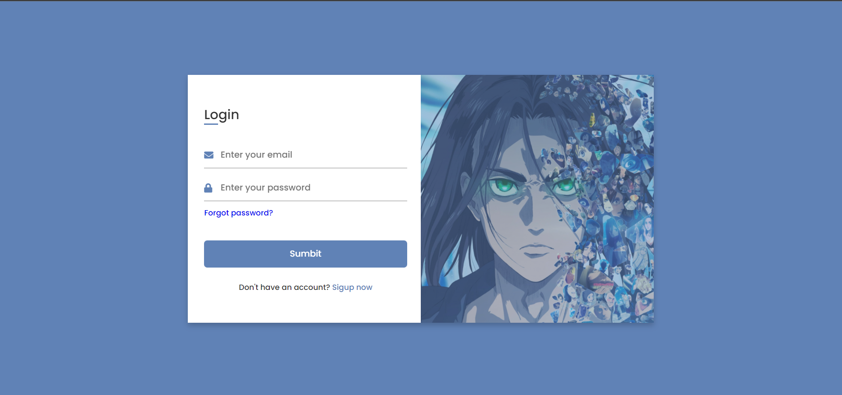

The user has to first signup before logging in. The user will be provided with an option to signup if they don’t have an account, at the bottom. Once registered, the user will have to provide proper email and password. Upon doing so they’ll be redirected to their dashboard.

* Sign up for an account

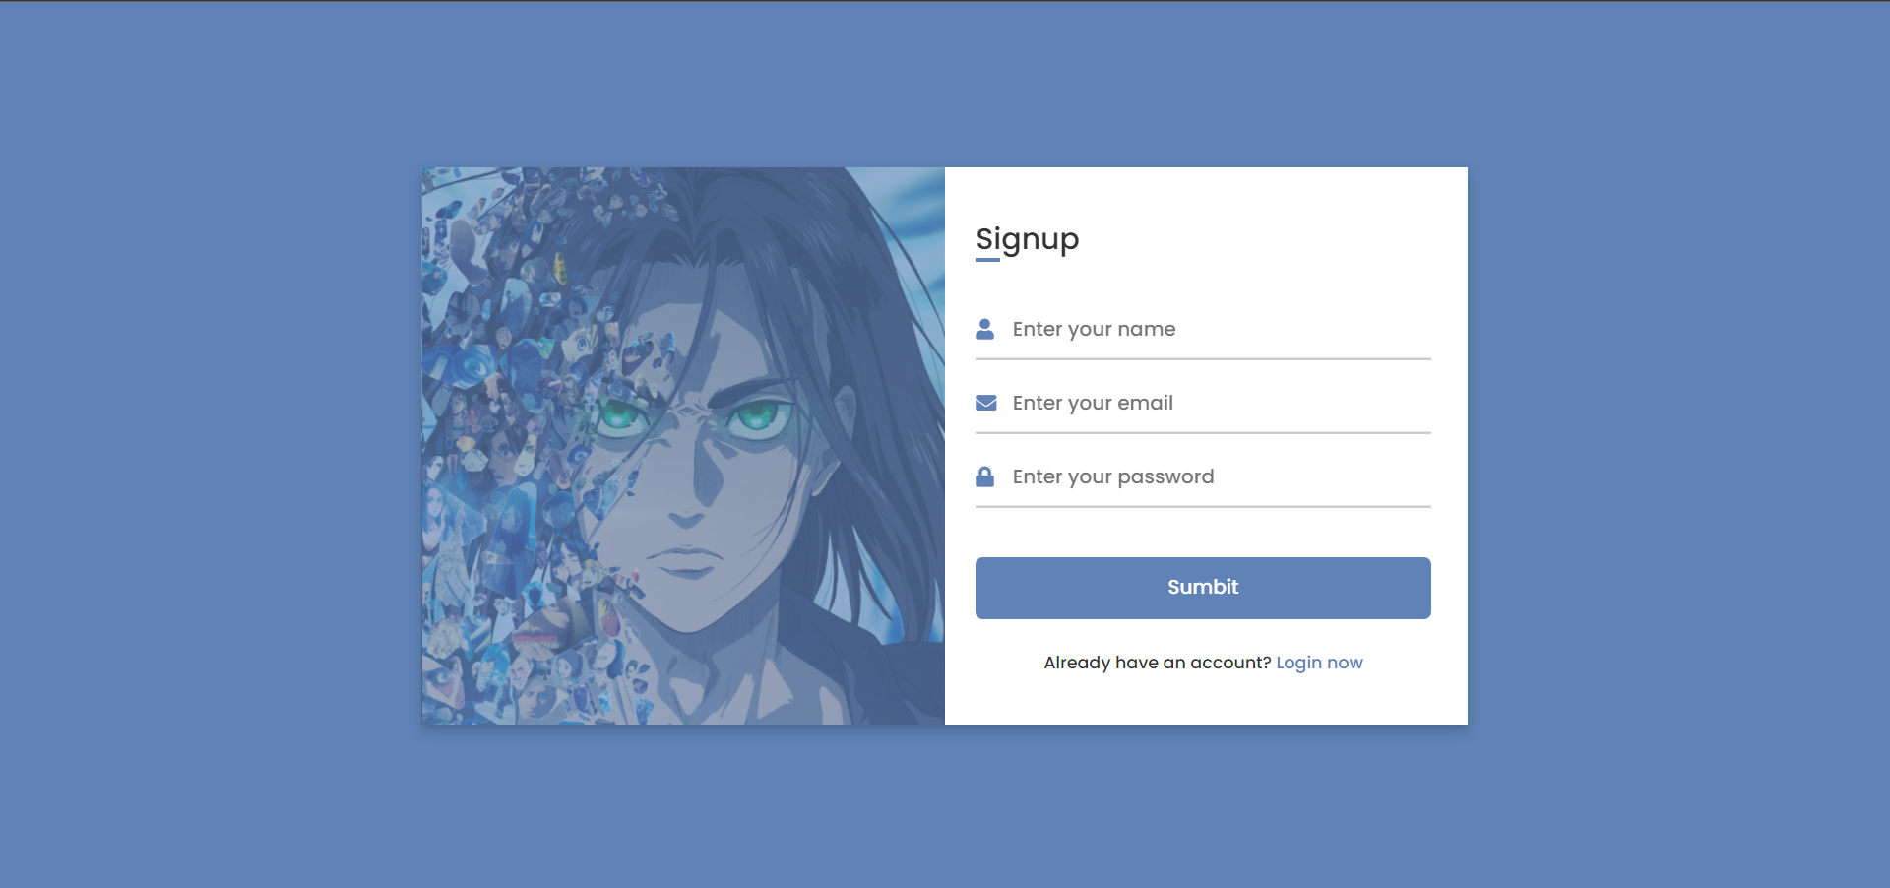

The user will have to provide the name, email and a password for the account. Valid email should be provided else the account will not be created.

* Home Page

1. Home
2. Explore
3. Individual Pages
4. About Us
5. BTS
6. Dashboard
7. Contact Us
8. Home -



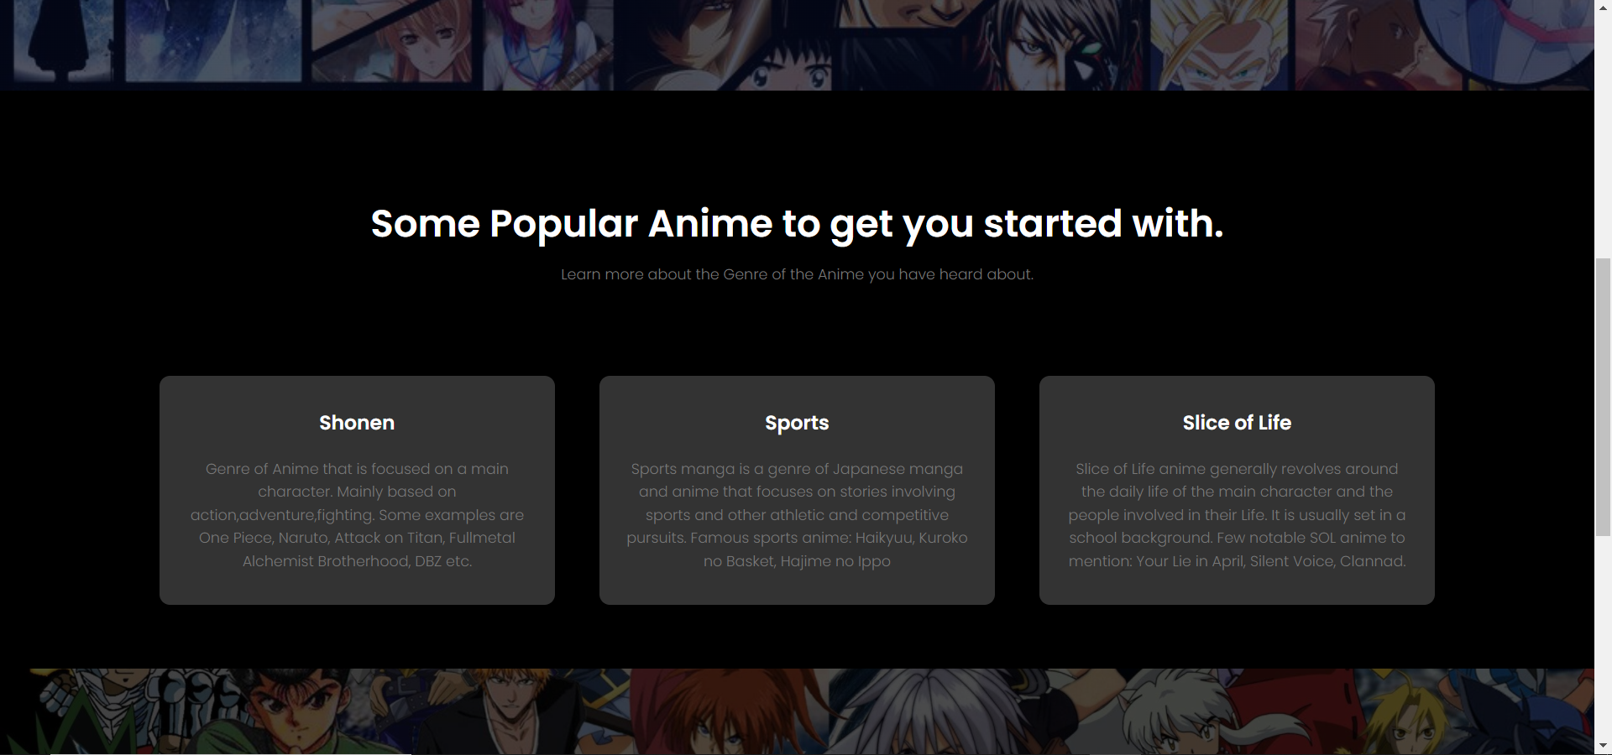



The home page is designed for the user to know about our website’s purpose and for providing information about different types of anime and its genre.  
There is an Explore button which hyperlinks to the “Explore” page where the user can explore more shows.

1. Explore-





This page contains the different shows in a carousel menu, where the user can traverse and can select any show of his interest.

1. Information on Individual Pages-

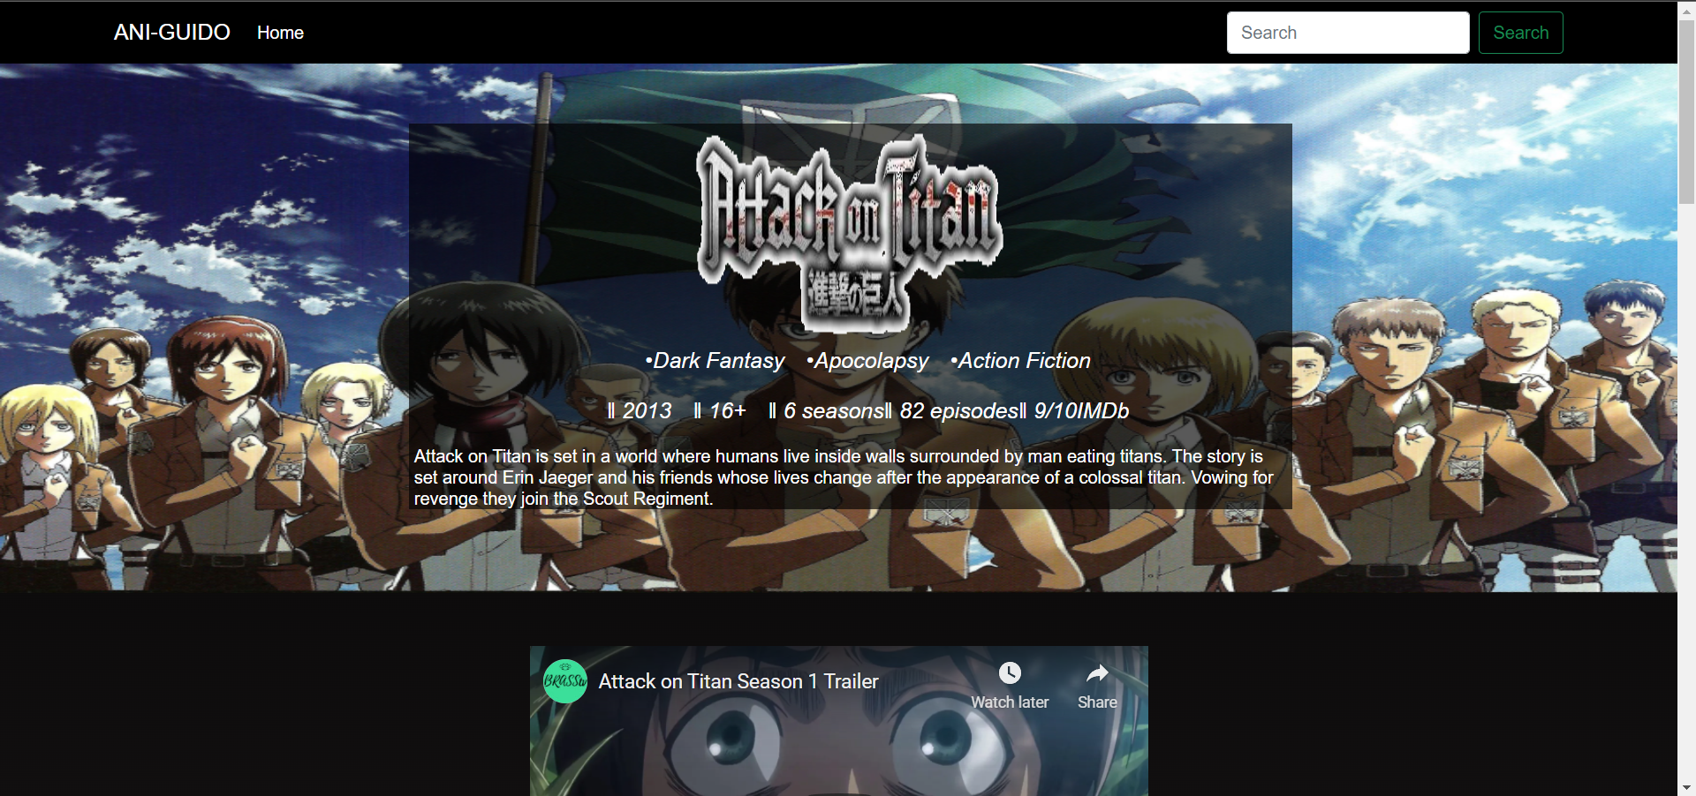

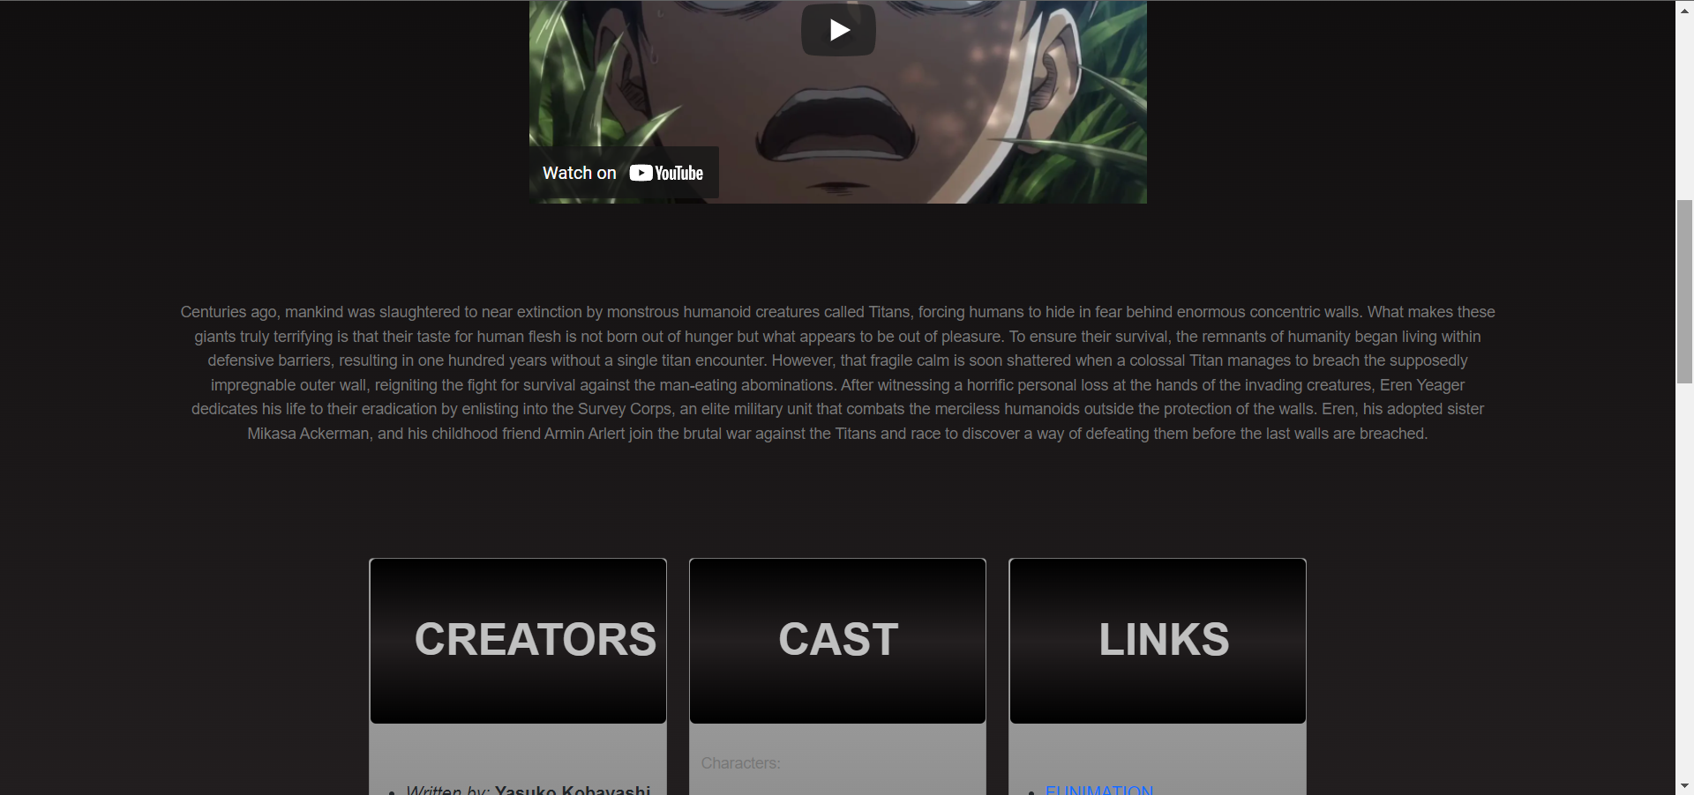

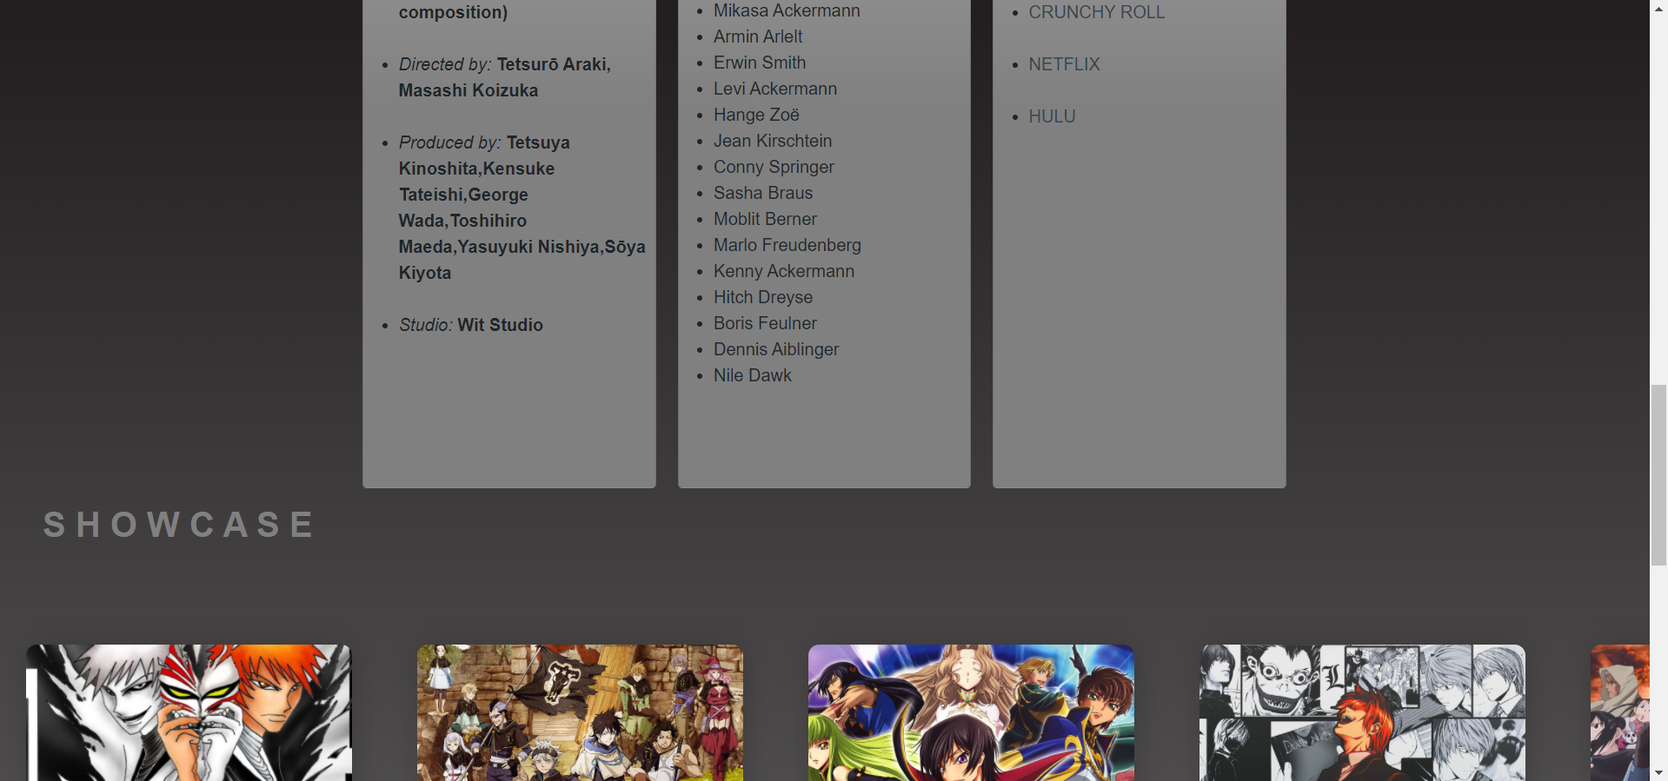

On clicking the icons in the carousel menu, individual pages of the respective shows are opened. These provide information on the shows episodes, ratings, creators and characters etc. There is a mini player which plays the trailer of the anime. In the bottom the carousel menu is given in case the user wants to check out another show. The user can add any show to his watchlist by clicking on the image icons.

1. About Us-

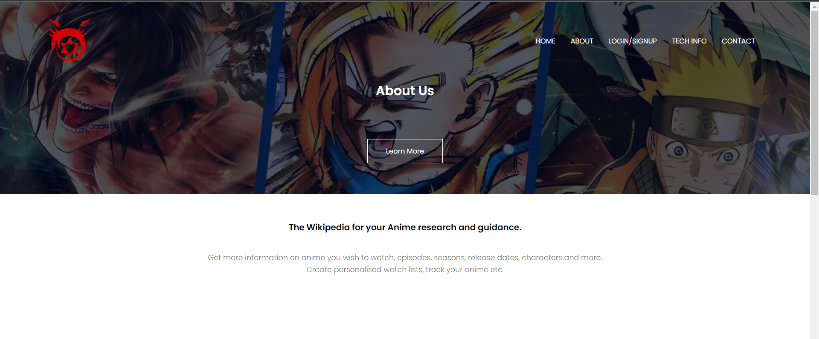

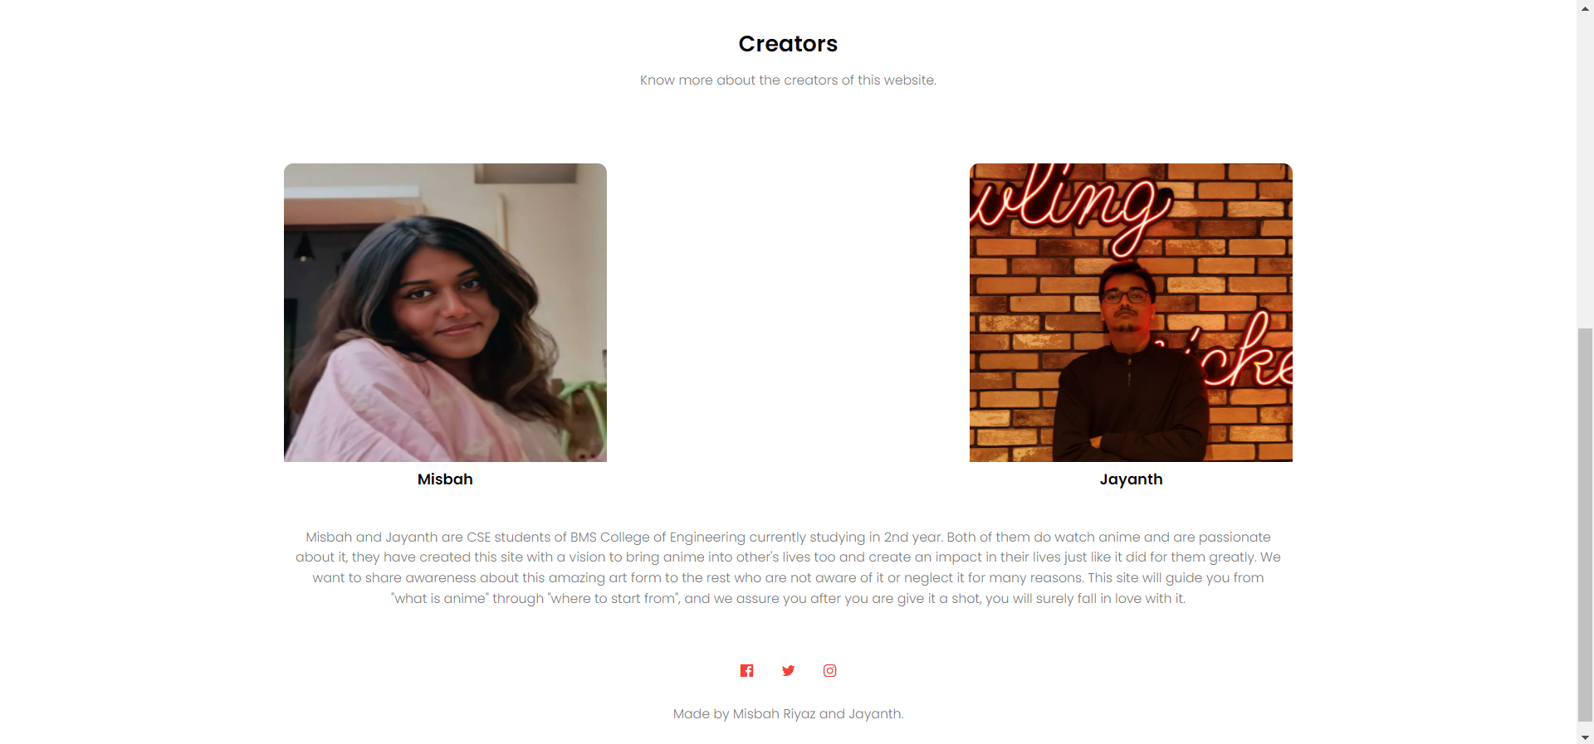

This briefs the user about the website and the creators of it. The user can explore more about anime, tech used, creation of anime since 1950’s etc. It also provides links for learning the user if they take liking into developing something of their own.

1. More about Anime-

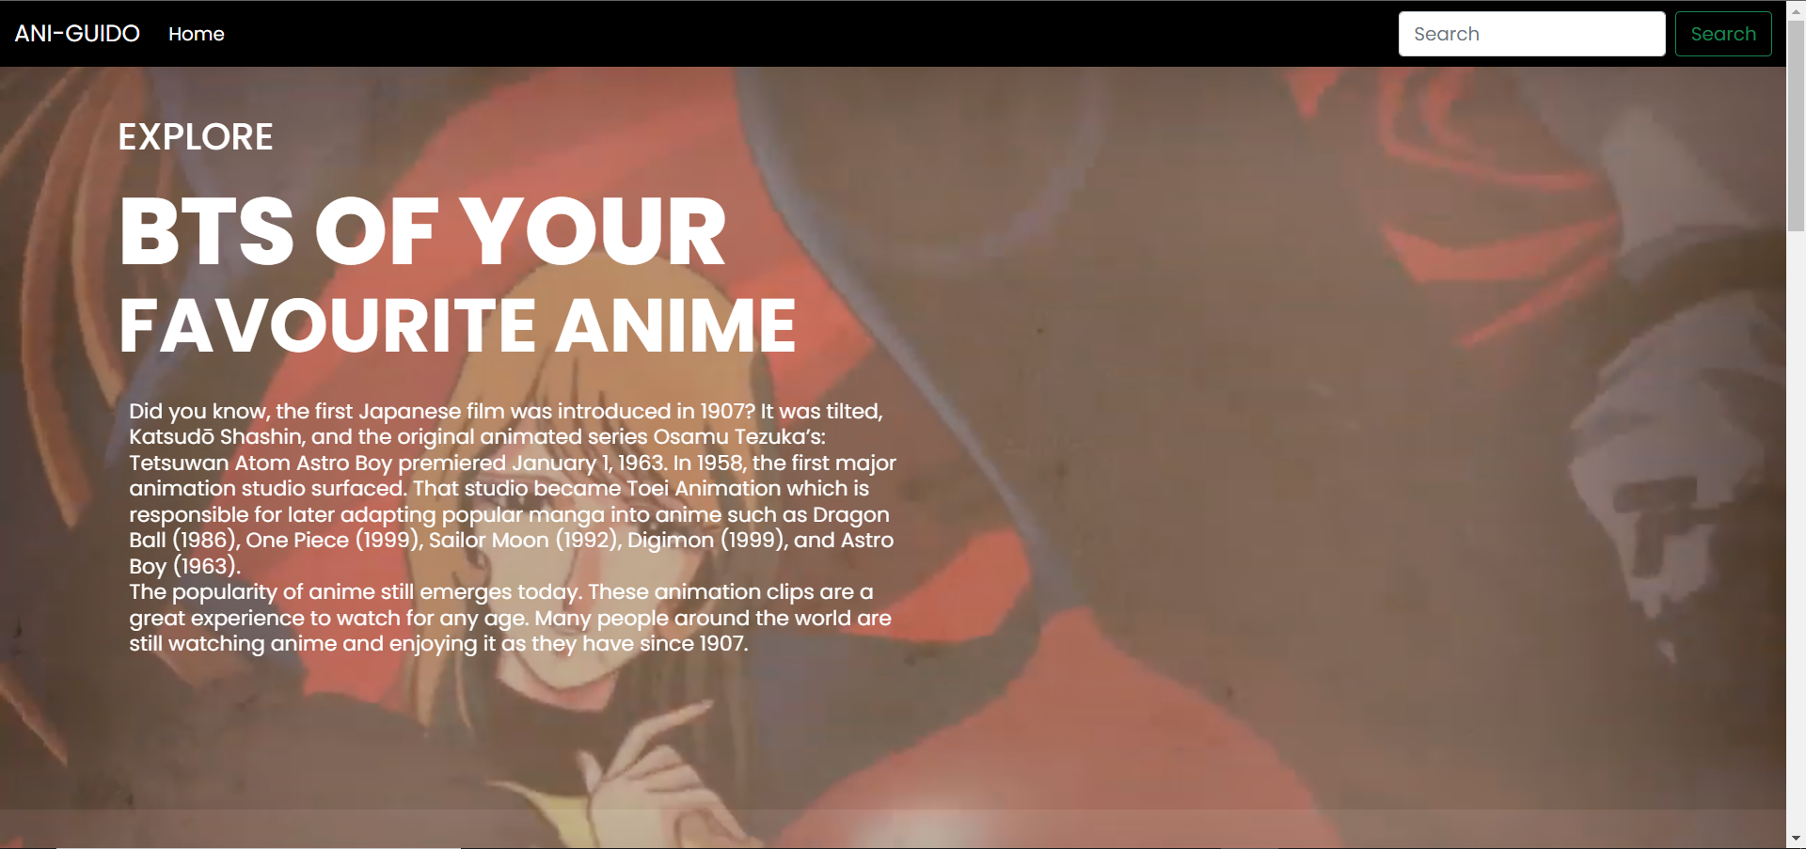

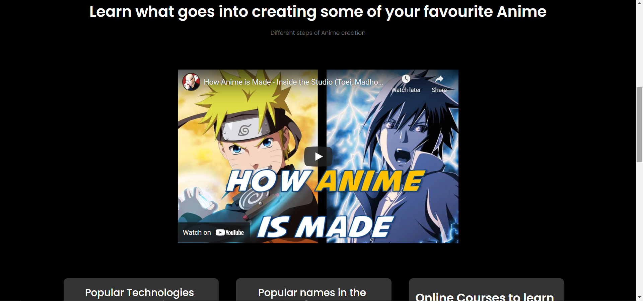

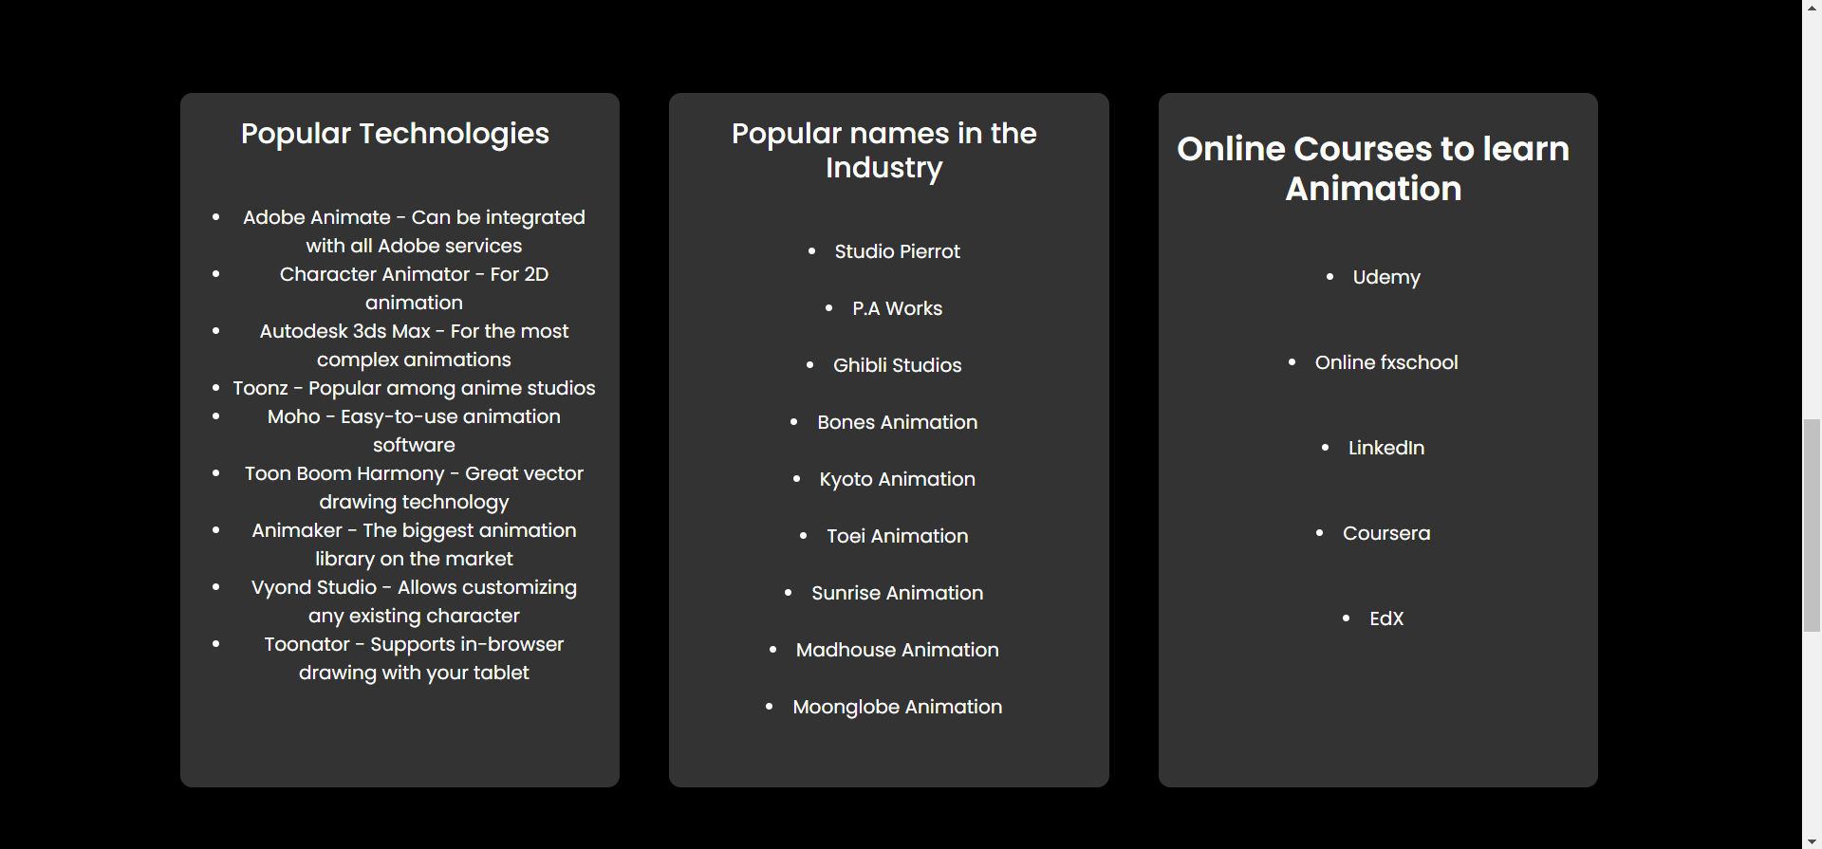

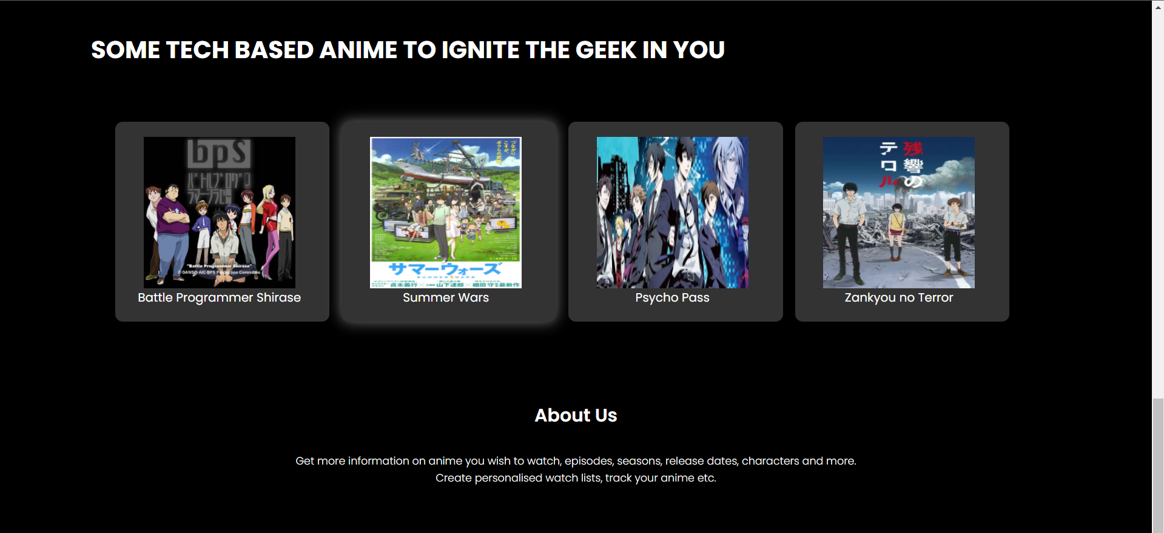

This page showcases behind the scenes of making anime, and the processes involved in it. It gives a brief history of anime, and also provides some tech-based anime recommendations. It provides the user platforms to learn animation from.

1. Dashboard-

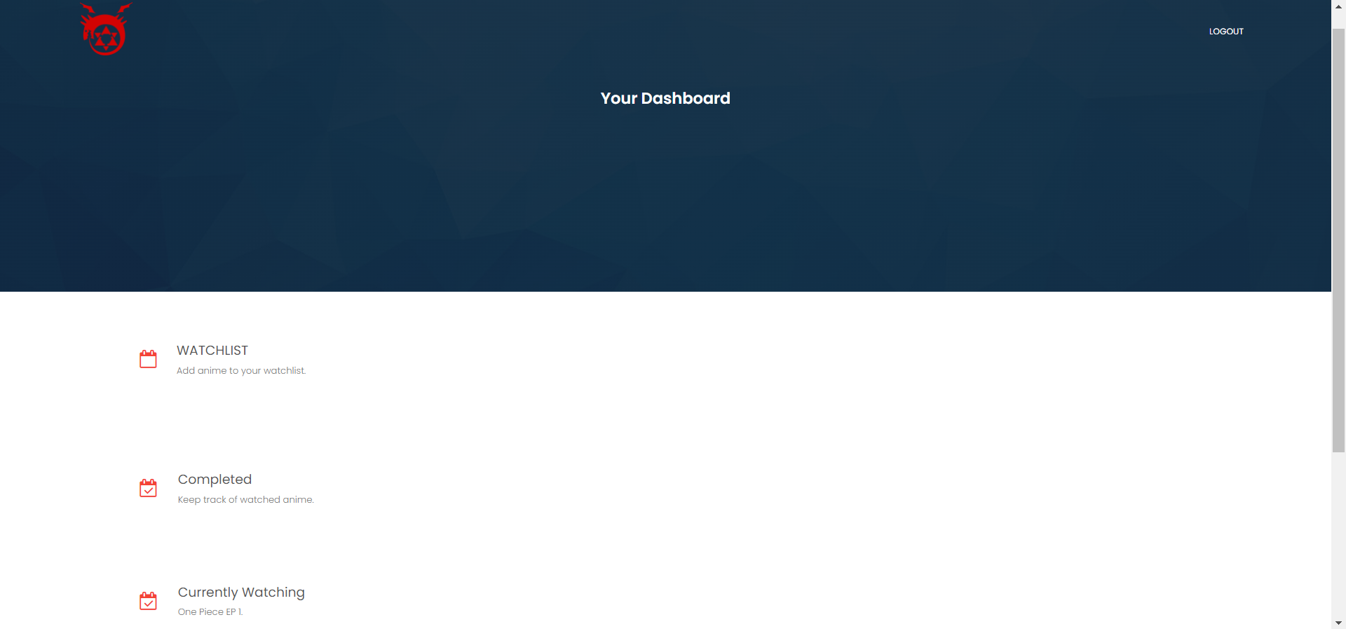

On successful login or signup, the user is re-directed to their dashboard where they can keep track of their watchlist and completed anime and currently watching list.

1. Contact Us-

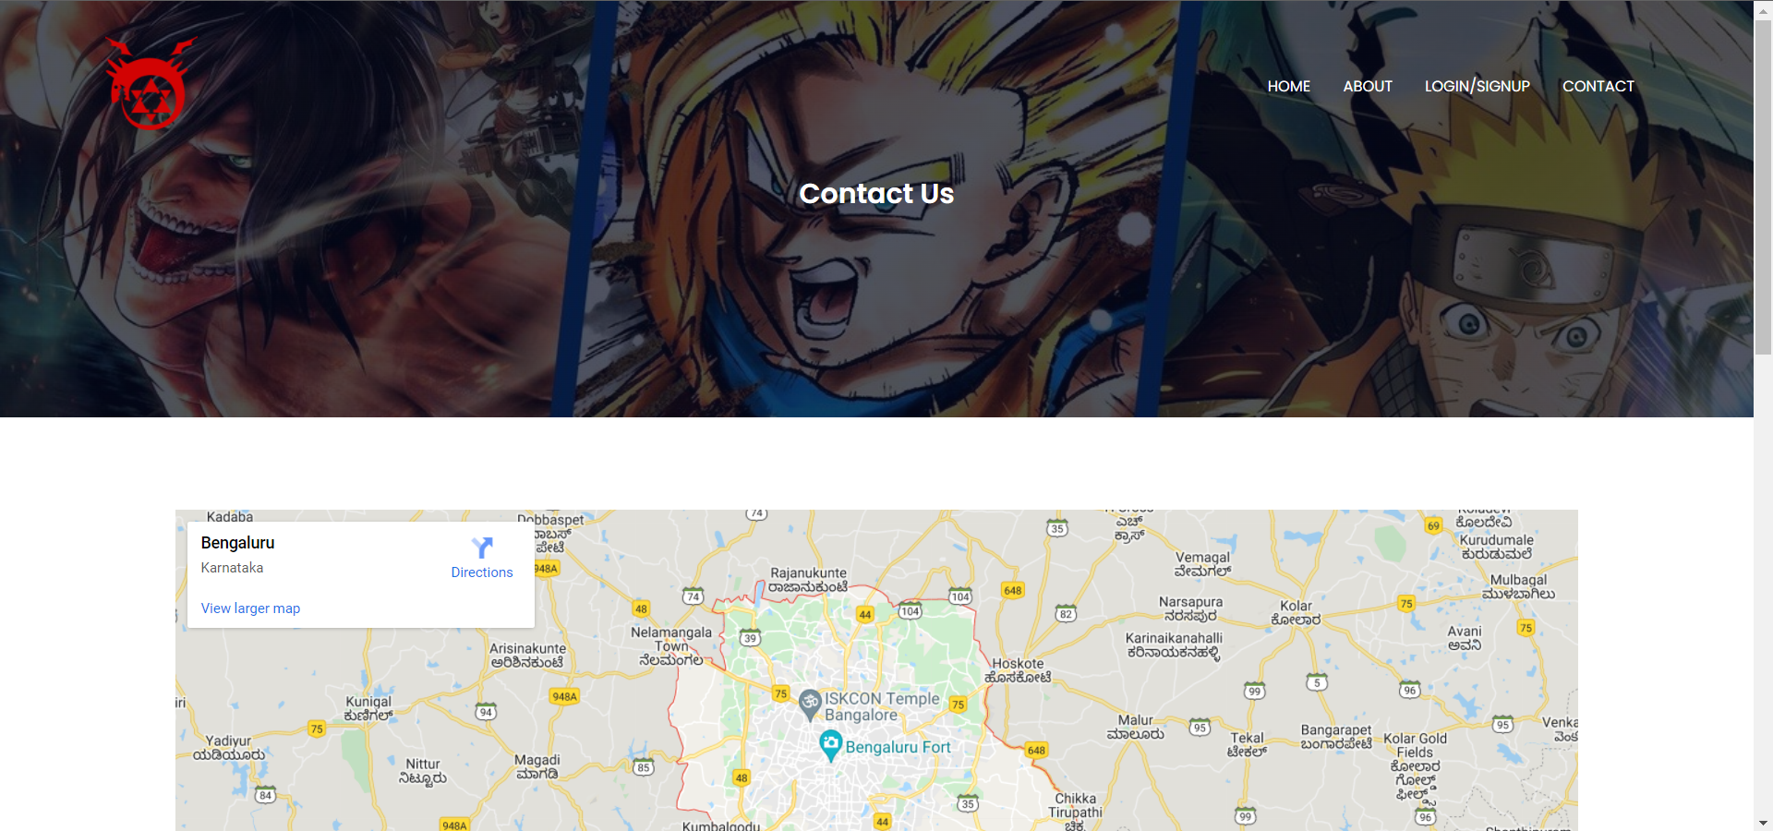

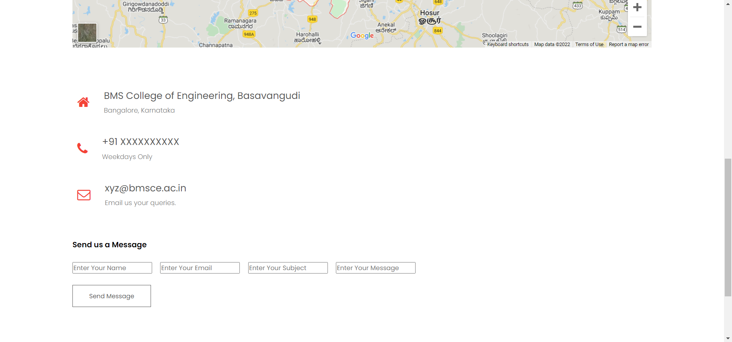

The contact us page allows the user to reach out to the creators of the site, incase of any wrong information or suggestions.  
There is also a message from which the user can fill and submit if they wish to.

* **PROJECT LAYOUT:**

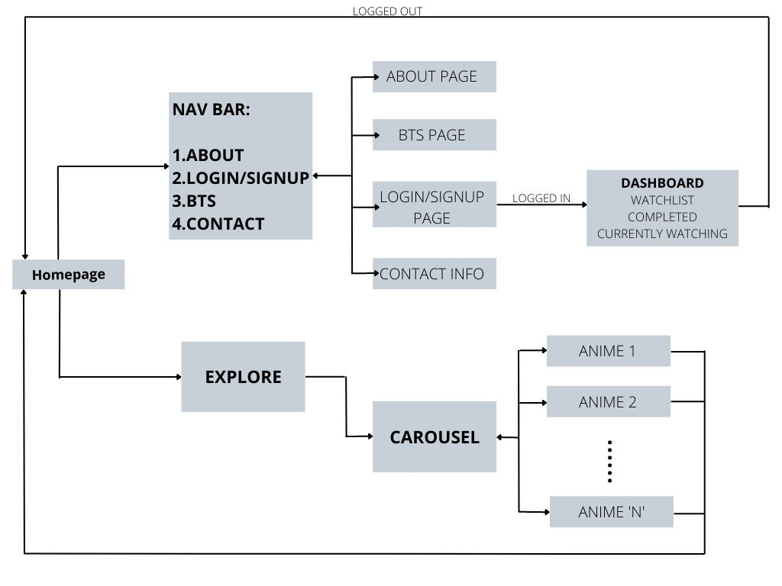

SOURCE CODE LINK:

The following link directs you to the GitHub repository which contain the source code to all of the above-mentioned webpages.

­­­­https://github.com/jayanth272/Project-Work.git